SEARCH ADVERTISING CAMPAIGN FOR LENSKART
Budget: ₹1,00,000 | Duration: 1 Month

- 3 key competitors of Lenskart in the Indian market:
- Titan Eye+
- Specsmakers
- Fastrack Eyewear

- Unique Selling Propositions (USPs) of Lenskart:
- Lenskart’s 3D Virtual Try-On helps customers digitally try thousands of frames for confident decisions.
- Strong value pricing with offers like Buy 1 Get 1 and 50% OFF attracts all shopper segments.
- Free home eye tests and home try-on services provide maximum convenience for customers.
- A wide range of 10,000+ trendy frames caters to every age group and budget.
- Lenskart’s omnichannel presence with 1500+ stores and a robust online platform ensures seamless shopping.

- Campaign Objective: Sales
This objective is ideal because the campaign aims to drive direct eyewear purchases, and Search Ads target high-intent users actively looking for eyeglasses and related products.

- Google Ads Setup Screenshots:
- Objective selection screen:
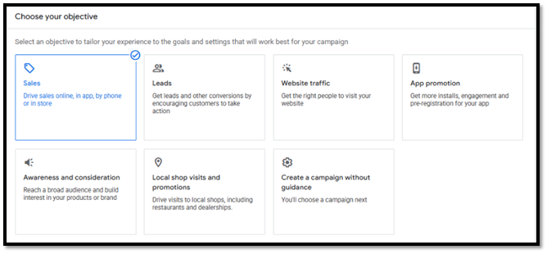
- Budget, dates and ad schedule:
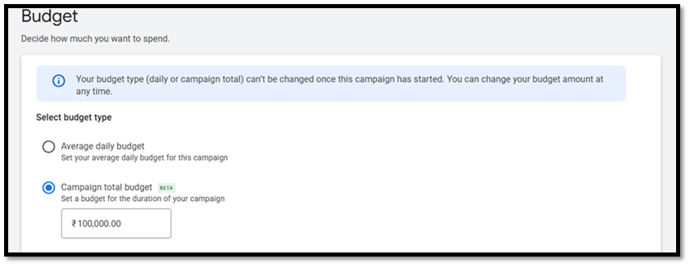
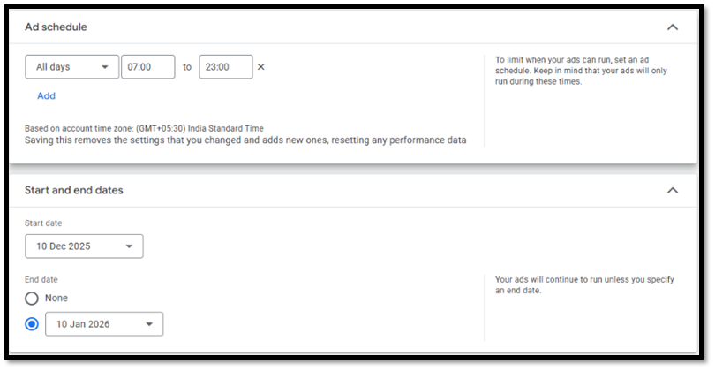
- List of keywords research for the campaign, with their search volume and competition.
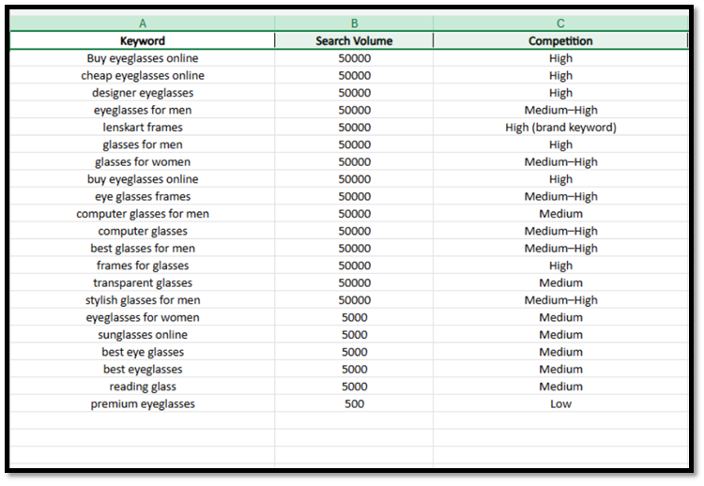
- Target audience setup:
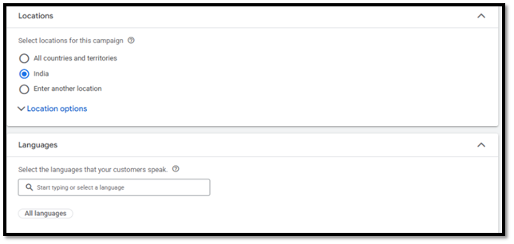
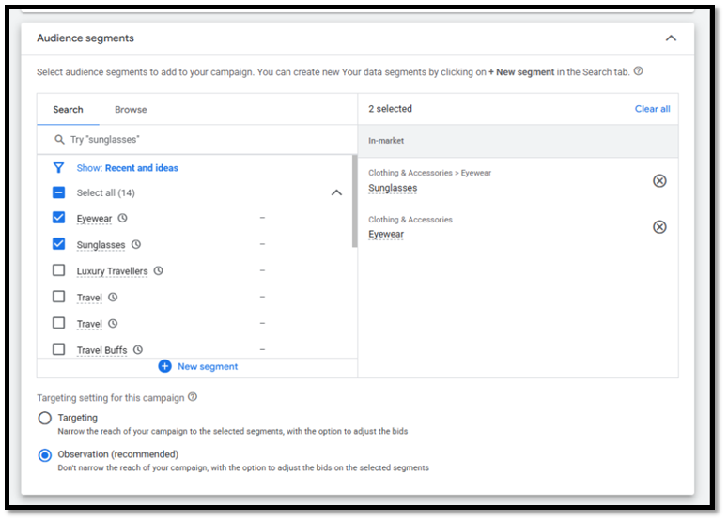
- Screenshot of your Ad creative:
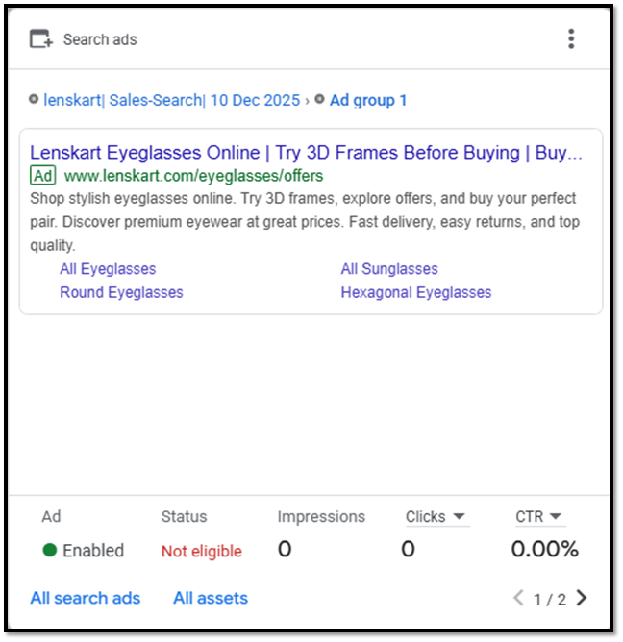
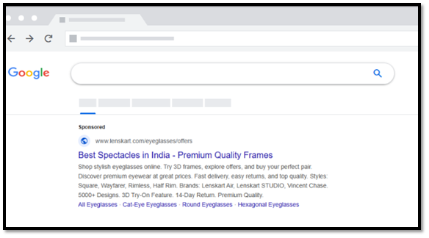
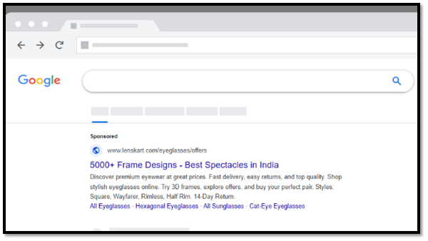
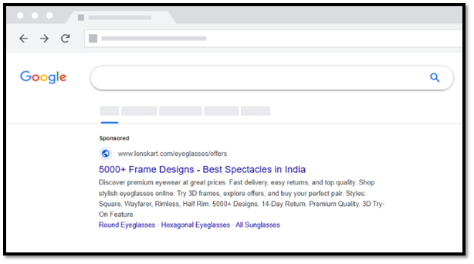
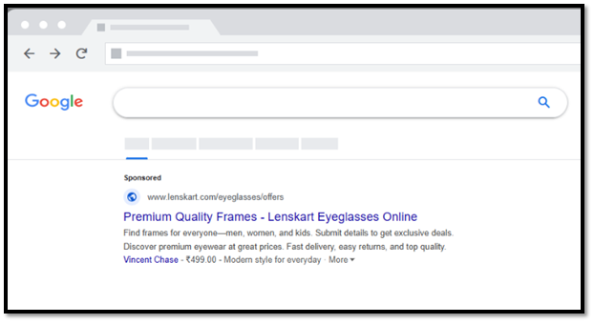
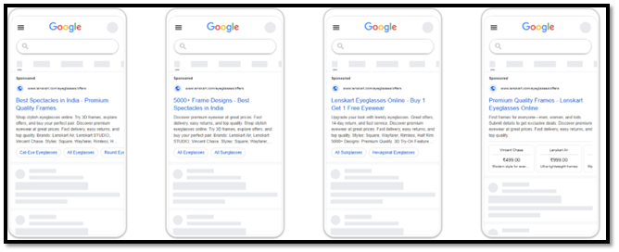
- 4 ad extensions:
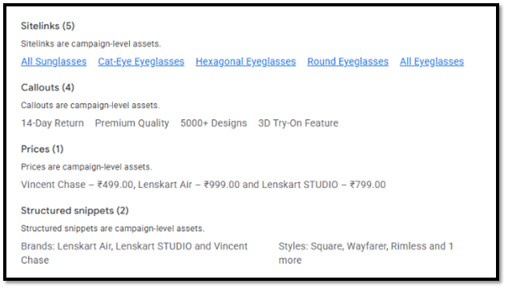
- Estimated campaign results:

